课后例句 Unit 5

Reading 1：

表示超纲词

1. Three generations of fishermen conduct an ***e________(漫长而艰难的)*** struggle against nature, fate, and society in this moving tale.
2. This island is a place of great adventures and ***e________英雄的；英勇的；史诗般的 )***tales, inhabited by five tribes.
3. We camped that night in a shallow valley ***a________(在…之中；被…环绕)*** low hills covered with green pine trees.
4. The dollar has fallen in value ***a________(在（嘈杂、纷乱的时间）中（用于书面语或新闻报道中）)*** rumors of weakness in the US economy.
5. For centuries, the Rocky Mountains have captivated visitors with their ***j_______(凹凸不平的；锯齿状的)*** peaks, magnificent waterfalls, and blue lakes.

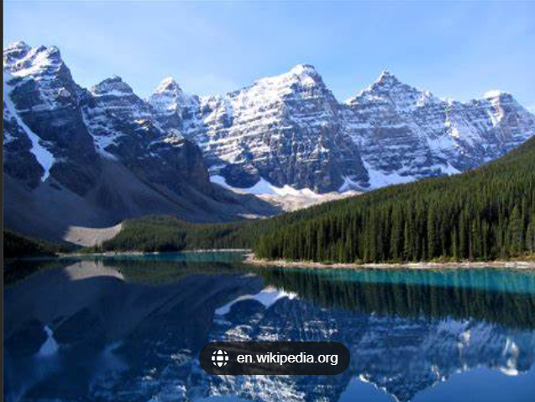

1. Just as the Sun began to break through an early-morning ***haze(烟雾，霾)***, I spotted three horses on a hill.
2. The light of the setting Sun ***t_______(着淡色于...；使带有一点（情绪、特质等）)*** the buildings with delicate colors.



1. The bright yellow ***s_______((色彩的)浓淡，深浅，色度)*** is meant to evoke the optimistic promise of a sunshine-filled day.





1. I spent most of the day walking on the shore or reading a novel in the ***s_______(背阴处；阴凉处)*** of a large umbrella.



1. My ***a_______ (感情或信念等)长久的，持久的)*** memory is of him watering his plants in the garden on sunny afternoons.
2. He is internationally recognized as a distinguished ***s_______ _______ （（尤指精于一门文科学问的）学者）*** in the field of Chinese studies.
3. Local people have to obey their ***c_______ _______ （征服者）*** because they want to go on living.
4. The vehicle ***s_______ _______ 通常为了避免碰撞）突然转向一边*** off the road, hit a lamppost and rolled several times before catching fire.

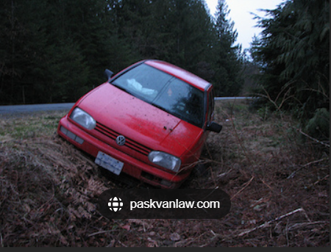

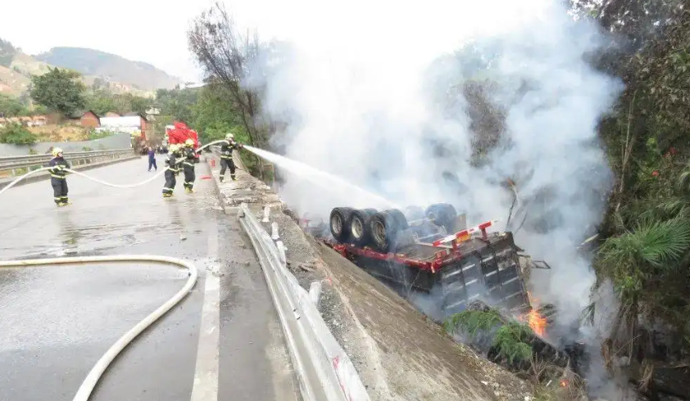

1. The performer shook, jumped and ***s_______ 一摆一动地走（移动）*** in perfect motion, spurring the crowd to rise in an emotional applause.
2. Hundreds of trucks full of fruit and vegetables ***t_______ _______ （使）缓慢移动（滚动）*** across the border each day.
3. c***______________***

1）尤指穿越沙漠地带的旅行队，商队

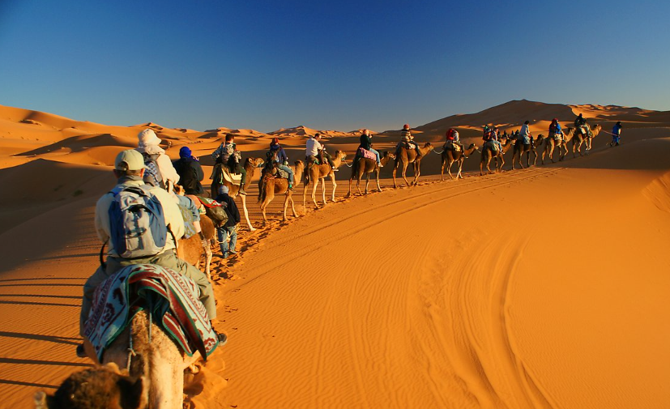

2）（AmE trailer） (带有食宿设备的)旅行拖车

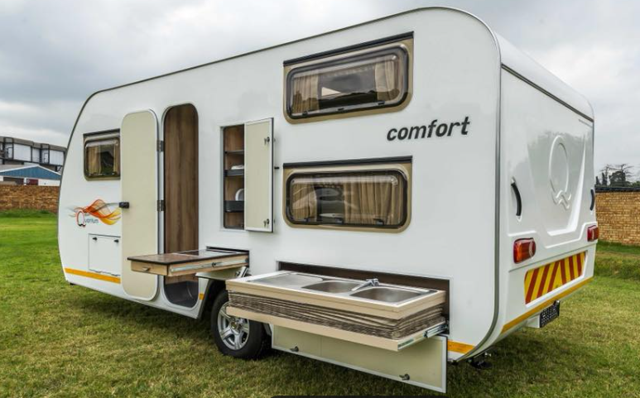

（讲练习）

1. s***___________*** 香料



1. A 25-year-old man was ***f___________(（用力）击倒（某人）)*** by that boxer with a single punch.
2. Fifteen million trees were ***f___________(砍伐（树木）)*** by the Great Storm which hit the south of England in 1987.
3. These birds are able to survive the ***p___________(（某活动或情况的）危险，凶险)*** of the Arctic winter.
4. This was the second time that he had put his life in ***p___________(巨大的危险（尤指受损或被杀）)*** to rescue someone at risk of drowning.
5. It should be noted that some parts of the world seem to be experiencing ***c___________(气候的)*** changes.
6. They crossed the bridge and ***t___________(跨过；穿过；横越；横穿)*** the road out into the open country.
7. They warned us that the northern half of the island was controlled by ***h___________(敌人的；敌方的)*** forces.
8. Rebecca was very ***h____________***The new oil contracts will amount to a half billion dollars' worth of foreign investment in their ***territory(领土；版图；领地)***.
9. He urged the United States to ***p____________坚持；执意)*** with its efforts to bring about peace.
10. After walking five miles, they had worked up a great ***t____________(渴；口渴)*** and decided to stop for water.
11. To put it another way, the analysis lacks both a sense of humanism and a theory of ***i____________(思想（体系）；思想意识).***
12. There will always be "lost in translation" moments, but that's part of the ***a____________(诱惑；魅力；吸引力)*** of foreign travel.
13. The ***i____________(固有的; 内在的; 本身的)*** value of a coin is the value of the metal it is made of.
14. There are plenty of ways to see the country this summer, but few can beat the ***r____________(传奇色彩；浪漫情调)*** of traveling on a steam train.
15. Hemingway's ***r____________(罗曼史)*** with his nurse inspired him to write *A Farewell to Arms.*
16. His refusal to work late was ***i____________(把⋯理解（解释）为)***as a lack of commitment to the company.
17. She couldn't speak much English so her children had to ***i____________(口译)*** for her while traveling in the UK.

（讲练习）

1. The feelings that arise in that condition are simpler, more understandable, and more ***d____________(持久的)***.
2. Fine bone china is very practical due to the fact that it is strong and ***d____________(耐用的).***
3. The new model is a ***t____________是⋯的证据；是⋯的证明)*** to the skill and dedication of the workforce.
4. As children, we were ***d____________(使…倾倒)*** by my uncle's good looks and charm.
5. Drivers are supposed to slow down or pull over when they are ***d____________ ((因强光、闪烁等）使…目眩；使…眼花缭乱)*** by bright sunlight. (= blind)



1. They are hoping to ***r____________(重走（别人走过的路程）)*** the epic voyage of Christopher Columbus.
2. By trailing a thread behind them spiders are able to drop from any height to the ground and to ***r____________(顺原路返回；折返)*** their steps with certainty to a particular spot.
3. Lingyin Temple is a famous ***B____________（佛教的)*** temple situated in the northwest of Hangzhou.

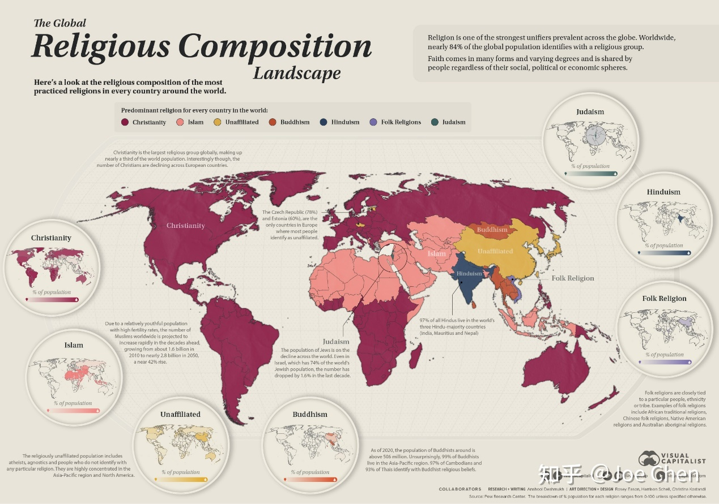

基督教、伊斯兰教、犹太教、印度教、佛教、

1. This ***g____________（小洞穴)*** houses the most exquisite stone sculptures from the Tang Dynasty. (注意拼写) 复数？-s, -es
2. The crowd ***d____________（缭缓移动；缓慢行走）*** away from the scene of the accident.
3. As our boat ***d____________（漂流；漂移）*** down the river, many children ran along the shore waving at us.
4. Yosemite National Park is an area of outstanding ***s____________（景色优美的）*** beauty and great wilderness value.
5. Enormous cloud ***f____________（（岩石或云朵的）形成物；形状）*** dominate the landscape on a hot, humid summer's day.
6. An agreement on the ***f____________（构成；组成）*** of a new government was reached on June 6.
7. The beach ***s____________（延伸；绵延）*** for more than two miles, backed by grassy dunes and sweet-smelling pine forest.

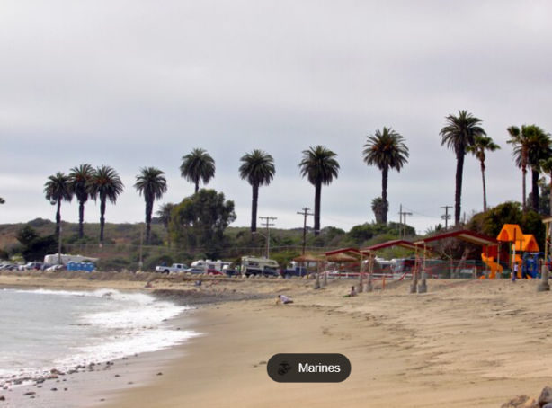

1. Once ***s____________（使）变大；（使）变松；拉长）***, the elastic band will not return to its original length.



1. A loose dog is at the risk of falling or being ***c____________ （把…弹（射）出去）***out of the truck bed.
2. You might gaze at the Grand Canyon with ***a__________（崇敬；赞叹）***，marveling at its beauty and fearing its death.

（讲练习）

1. We cannot cure the world of ***s__________（令人悲伤的事；不幸）***, but we can choose to live in joy.
2. The president expressed his deep ***s__________（悲伤，悲痛）*** over the bombing deaths.
3. The report calls for a ban on the import of ***h__________（危险的；有害的）*** waste.
4. That's probably the most bare, ***b__________（无遮掩的；荒凉的；索然无味的***）, and inhospitable island I've ever seen.
5. They had to overcome ***f__________（令人敬畏的；可怕的）*** obstacles during their journey.
6. Penguins employ cooperative behaviors in order to deal with an incredibly ***h__________恶劣的；艰苦的；严峻的）***environment.
7. The solar cooker looks impressive, with mirrors designed to catch the ***h__________（刺眼的；耀眼的）*** sunlight, focusing their power to create intense heat.
8. Millions of people in that region are threatened with ***s__________（饥饿；挨俄；饿死）*** as a result of drought and poor harvests.
9. The ancient ***c__________（文明（社会））*** of Central and Latin America were founded upon corn.
10. It would be helpful if you were to ***p__________先于…（发生或出现））*** the report with an introduction.
11. Running a marathon is seen by many people as the ultimate test of human ***e__________（（忍）耐力）***.
12. Dean ***t__________（用计诱使某人做某事）*** the old lady into giving him 800 pounds, claiming that he would invest it for her.
13. When Captain Cook ***s__________ s__________（起航） for*** the Pacific, he was heading to parts of the world that were little-known. Set sail from/to/for ...
14. We struck up a conversation, ***in the c__________of （在⋯期间）***which it emerged that he was a sailing man. during/in/throughout the 。。。of
15. The rescue team also had bad weather conditions to ***c__________ w__________（（不得不）处理问题，对付困境）***.